

February 11, 2009

TO: Ron Severtis, Program Assistant, ASC Advising and Academic Services

FROM: Valerie Lee, Chair, Department of English 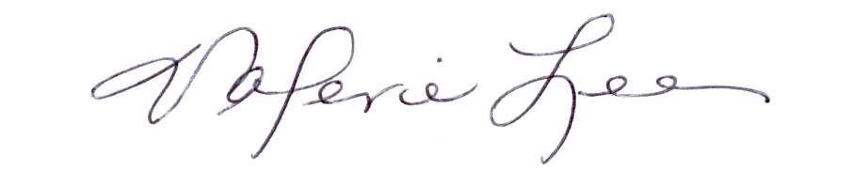

RE: Proposal for HUM 550

Faculty in Rhetoric, Composition, and Literacy Studies (RCL) and the Writing Program Directors within the English Department have reviewed the proposal for HUM 550, “Writing Center Theory and Practice.” Summarized below are their response and recommendation regarding the course. In short, the faculty and staff do not support the proposed course as presented as it (1) duplicates significantly an already existing course (English 467) and (2) does not meet the expected rigor of a 500-level course. I concur with the assessments of the RCL faculty and Writing Program Directors.

RCL Faculty and Writing Program Directors’ Response to HUM 550 Proposal
Upon its receipt in early February, the HUM 550 proposal was distributed electronically to all RCL faculty for comment and then discussed by the Writing Program Directors at their February 11, 2009 meeting. Although these faculty and staff appreciate the efforts on the part of CSTW to provide further classroom-based opportunities for undergraduates to explore tutoring and writing center practice, they do not support approval of the course as presented. Concerns focus on two central issues:

- HUM 550 duplicates significantly portions of the content in English 467. English 467 has many of the same course objectives articulated for 550, including introducing students to current theory and practice in tutoring, providing practical experiences in tutoring, investigating students’ own writing practices and assumptions about writing and tutoring, examining issues of diversity and difference, and providing service learning opportunities. It is the case that 550 focuses more on one-on-one tutoring in the writing center context while 467 focuses its practical elements on tutoring in classroom-based and collaborative writing groups, but these differences are not significant enough to warrant a second course as proposed. English 467 is currently offered each Autumn and Winter Quarter and has, with this frequency, always met student demand and can easily absorb enrollment of additional students.

- HUM 550 does not meet the expected rigor of a 500-level course.
The curriculum (course content, readings, and assignments) is largely practical in nature, limiting students’ opportunities to examine theoretical principles foundational to informed practice. In short, the course does not have a sufficient theory component and is rather thin in the rigor and number of course readings and related course assignments. As conceptualized, the course is, rather, a practicum that might be better constructed as a lower-division (e.g., 300-level) course.

Recommendation
While RCL faculty and the Writing Program Directors do not support approval of the course as proposed, they welcome the opportunity to collaborate with CSTW Directorship on revising ENG 467. Writing Program Directors expressed interest in partnering with CSTW and the University Writing Center to refine 467 to better reflect the needs of undergraduate tutors, as well as foster exchange that could lead to increased enrollment.

